Clear and Informative Title [Times New Roman 16, Bold, Capitalize Each Word, Spasi 1.15, Align text left] [maksimal 15 kata]

First Author^{1*}, Second Author, Third Author [Times New Roman 12, Bold]

¹ Department / Faculty, Institution/University, Country [Times New Roman 11]

*email: correspondent author

Note: Write (*) after correspondent name and write down your email (institution email is preffered) and erase this writing after

DOI: https://doi.org/10.31603/bisnisekonomi.v16i2.2602

 | ABSTRACT
Keywords:  Write 3-5 keywords that explain the substantial of this article and separate it by semicolon (;) | Abstrak harus dibuat singkat, menarik, sederhana, dan mudah dipahami tanpa membaca keseluruhan artikel. Untuk itu, hindari menggunakan jargon, singkatan dan referensi. Dalam menuliskan abstrak, penulis harus akurat, menggunakan kata-kata yang tepat, dan menyampaikan makna penelitian. Abstrak yang baik memuat permasalahan dan tujuan, bagaimana riset dilakukan (metode), hasil, dan ditutup dengan pernyataan singkat kesimpulan. Dalam abstrak juga selalu disertakan kata kunci (keywords). Keywords digunakan untuk mengindeks sebuah artikel dan merupakan label dari sebuah artikel. Abstrak dibuat dalam 2 bahasa, English dan Indonesia (times now roman 11 pt, 1.0 space, italic)
 | ABSTRAK
Article Info:  Submitted:  01/05/2019  Revised:  10/06/2019  Published:  03/07/2019 | Times new roman 11 pt, 1.0 space

INTRODUCTION [Times New Roman 12 pt, 1.25 space, Bold]
The author masters the research that has significance or contributes to the field of study studied. The introduction contains "What do you / others do? Why did you do it? " Researchers also do not need to convey the definition of a term if it is not an important part of the discussion of the topic raised.
A good introduction must be able to answer the following questions and be presented in paragraph form.
- What is the problem that must be solved (problem statement).
- What people have done to solve existing problems, from time to time (state of the arts).
- What has escaped the attention of previous researchers or what the potential is available and not yet explored by other researchers.
- What concepts are offered to fill in the "blanks" or something that has escaped the attention of previous researchers.
- What is to be achieved from this work (research objectives)

LITERATURE REVIEW

This part contains of the theory that may strengthen and support the research and author’s logic. However, don’t write down any definition for this part.

METHOD
The research method section is written based on the question "how is the problem solved". If a manuscript proposes a new method, all information about the new method must be presented in detail so that the reader can reproduce the experiment. However, the author does not need to repeat the details of an established method, just use references and supporting material to show the established procedure.
It is important to note that methods must be written in the same order in the results section. The order of writing the method must also be logical according to the type of research conducted. The method for one type of research will be very different from other studies. For example, the presentation of survey research methods for which data will be processed with statistics is very different from the presentation of laboratory test research methods that involve a lot of equipment and materials. Part of the method can be made with several separate subtitles such as materials, tools, and data collection procedures.

RESULT AND DISCUSSION
In this section, the author must respond "what is meant by the results obtained and claimed as research findings". This section is the part that seems easy to write, but is the hardest part to get it right and this is the most important part of an article. Most of the manuscripts received serious attention from editors and reviewers because the discussion was weak, and many were even returned for re-submission or rejected. In this part of the discussion, the writer needs to make a "discussion" in accordance with the results of the research presented, but do not repeat the results. The author needs to compare the results of the study with the results of previous studies (some of which are contained in the introduction). It may be that a research result reinforces the research results of others, improves, or even contradicts. Whatever the outcome, the writer must make a "dialogue" with the results of other people's research, based on the existing grand theory. If the findings turn out to be different from other people's findings, this may be extraordinary, and in turn, the writer must face it and convince the reader that this finding is true or better than it is. Although this truth also sometimes does not last for a long period of time, because it will be perfected with new truths reported by other researchers. That's how science works.

Some tips for making a discussion on a manuscript:
  - Avoid statements that go beyond the results of the study, if valid data support is not available.
  - Avoid nonspecific expressions such as "temperature too high", quantitative descriptions are much better (write 105 ° C to express the measured temperature).
  - Avoid the sudden introduction of terms, including new abbreviations that are not standardized; the writer must present everything in the introduction, before all of that is present suddenly in the discussion.
  - Speculation about possible interpretations is permissible, however, it must be rooted in reality, not imagination. To achieve good interpretation, several things need to be considered:
    - How do the results of this study relate to the research question or initial objectives outlined in the introduction.
    - Does the data obtained support the hypothesis that was created when making a research proposal.
    - Are the results of this study in accordance with what has been reported by other researchers.
    - If the results of this study are unexpected, the writer needs to provide and explain the reasons, including what are the strengths and weaknesses.
    - Are there other ways that are newer and easier for readers to interpret the results of this study.
    - What further research is needed to answer questions that cannot be revealed from this research. g. Explain what is new from this finding, without exaggerating.

CONCLUSSION
The conclusions section contains a summary of research results or research findings, which correlate with the research objectives written in the introduction. Then state the main points of the discussion. A conclusion generally ends with a statement about how research works contribute to the field of study as a whole (implications of research results). A common mistake in this section is to repeat the results of an experiment, abstract, or be presented with a very list. The concluding section must provide clear scientific truths. In addition, the conclusions can also provide the limitation of the study and suggestions for future experiments.

ACKNOWLEDGEMENT (if any)
In the acknowledgment section, the author can state the source of research funding and more specifically to the contract number. Make sure the statement complies with the guidelines provided by the funding agency. The author can also express his gratitude to reviewers and proofreaders, or supplemented by technicians who help prepare equipment set-ups or students who assist in surveys.

REFERENCES
Bibliography and references of at least 80% must come from primary reference sources (scientific journals and proceedings) and published the last 10 years to explain the progress of research. Bibliography written with Times New Roman 12 pt, 1.0 space. The style of environment used is the 6th APA (American Psychological Association) and we recommend using management references, such as Mendeley, Zotero, EndNote etc. The following is an example of writing a bibliography.

Abraham, R., & Harrington, C. (2013). Measuring Profit in Cooperatives : Definition and Methods. International of Business, Humanities and Technology, 3(4), 21–33.
Aqza, Y., & Darwanto. (2017). Pengaruh pembiayaan murabahah, musyarakah, dan biaya transaksi terhadap profitabilitas bank pembiayaan rakyat syariah. Iqtishadia, 10(1), 225–245.
Auditya, L., & Afridani, L. (2018). Pengaruh Pembiayaan Musyarakah Terhadap Profitabilitas Pada Bank Umum Syariah (BUS) Periode 2015-2017. Jurnal Baabu Al-Ilmi, 3(2), 102–118.
Bank Indonesia. (2012). Kodifikasi Peraturan Bank Indonesia Kelembagaan Penilaian Tingkat Kesehatan Bank. Jakarta: Pusat Riset dan Edukasi Bank Sentral.
Ghozali, I., & Latan, H. (2012). Partial Least Square, Konsep Teknik, dan Aplikasi menggunakan program SmartPLS 3.0 untuk Penelitian Empiris. Semarang: Badan Penerbit Universitas Diponegoro.
OJK. (2018a). Snapshot Perbakan Syariah Indonesia Juni 2018. Jakarta.
OJK. (2018b). Statistik Perbankan Syariah Desember 2018. Jakarta.

Figure and Table

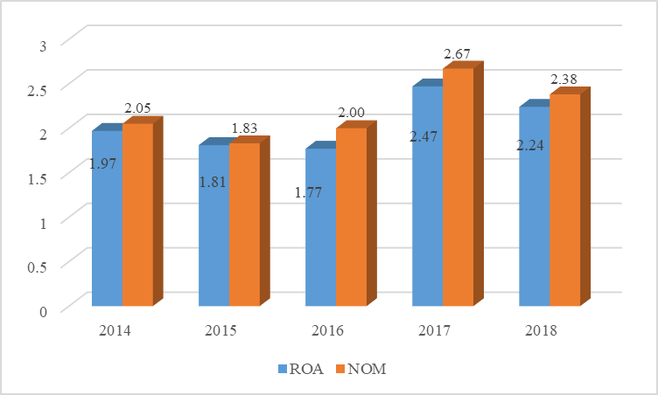
Figure 1. Sharia Bank Financial Data 2014-2018
Sumber: OJK (2018) reprocessed

Table 2. PLS Criteria
No | Criteria | Explanation
1 | Measurement Model Evaluation | - loading faktor 0.6  - Composite reliability > 0.60.  - Averange Variance Extracted (AVE) > 0.50  - Cronbachs Alpha > 0.70
2 | Structural Model Evaluation | - Significant P_{value} < 0.05  - bootstrapping.

Additional Info

- All figures, tables and equations must be mentioned in the paragraph before the figures, tables and equations are displayed. Avoid the words "Next picture, Table above, Equation below", substitute with the clear statement of Figure 1, Table 3, Equation (4), and so on.
- Use Indonesian or English properly and correctly.
3. Ignore the writing marked with a yellow block

This work is licensed under a Creative Commons Attribution-NonCommercial 4.0 International License

